RISULTATI KNN DATASET NON BILANCIATO

[+] Exec the KNN algorithm [Training]
modello addestrato,attendere prego…

{'Normal': {'precision': 0.9554890553718662, 'recall': 0.9635139697813793, 'f1-score': 0.9594847332254607, 'support': 47388.0}, 'Dos': {'precision': 0.9924742743050222, 'recall': 0.9841608285105087, 'f1-score': 0.9883000688231246, 'support': 13132.0}, 'Fuzzy': {'precision': 0.9848498117173132, 'recall': 0.949831081081081, 'f1-score': 0.9670235177780644, 'support': 11840.0}, 'Impersonification': {'precision': 0.9067504864541236, 'recall': 0.9128076343545957, 'f1-score': 0.909768978549796, 'support': 19910.0}, 'accuracy': 0.9537552834073914, 'macro avg': {'precision': 0.9598909069620813, 'recall': 0.9525783784318911, 'f1-score': 0.9561443245941114, 'support': 92270.0}, 'weighted avg': {'precision': 0.9540035925237904, 'recall': 0.9537552834073914, 'f1-score': 0.9538254888402745, 'support': 92270.0}}
Confusion matrix:
[[45659 22 110 1597]
[ 133 12924 10 65]
[ 362 25 11246 207]
[ 1632 51 53 18174]]

[+] Exec the KNN algorithm [Testing ADV],attendere prego…

{'Normal': {'precision': 0.889810001792436, 'recall': 0.41903013421119273, 'f1-score': 0.5697520945713302, 'support': 47388.0}, 'Dos': {'precision': 0.2745046639141927, 'recall': 0.9568991775814804, 'f1-score': 0.42662411516067156, 'support': 13132.0}, 'Fuzzy': {'precision': 0.4598641280057209, 'recall': 0.8690033783783784, 'f1-score': 0.6014496989536448, 'support': 11840.0}, 'Impersonification': {'precision': 0.42373821408763174, 'recall': 0.0383726770467102, 'f1-score': 0.07037258785059641, 'support': 19910.0}, 'accuracy': 0.4711823994797876, 'macro avg': {'precision': 0.5119792519499953, 'recall': 0.5708263418044404, 'f1-score': 0.41704962413406077, 'support': 92270.0}, 'weighted avg': {'precision': 0.6464997369625406, 'recall': 0.4711823994797876, 'f1-score': 0.44569332174653375, 'support': 92270.0}}

Confusion matrix:
[[19857 19713 6804 1014]
[ 17 12566 547 2]
[ 173 1355 10289 23]
[ 2269 12143 4734 764]]
time=
341.75477719306946 secondi

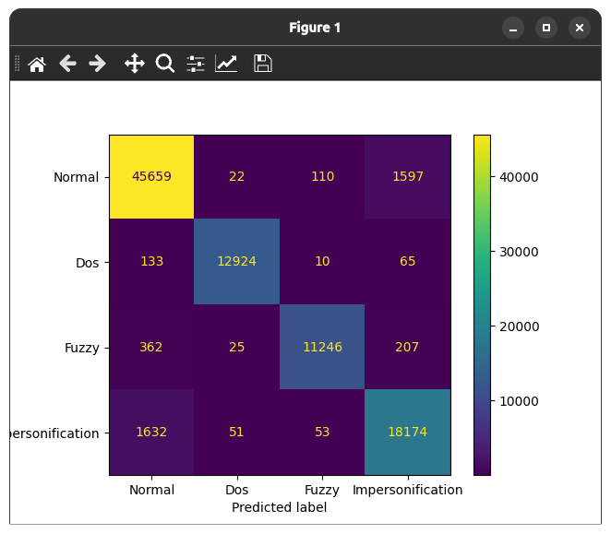
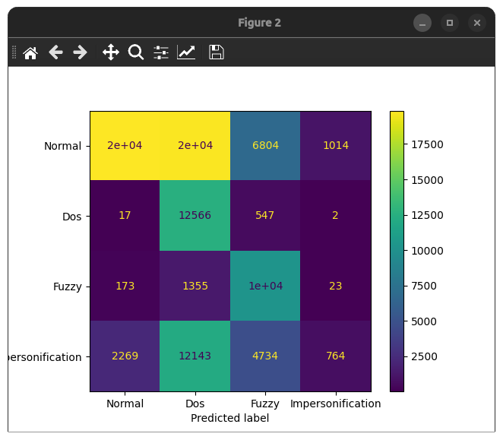

RISULTATI KNN CON DATASET BILANCIATO

[+] Exec the KNN algorithm [Training]
modello addestrato,attendere prego…

{'Normal': {'precision': 0.9717845044257458, 'recall': 0.938296615176838, 'f1-score': 0.9547470019217762, 'support': 47388.0}, 'Dos': {'precision': 0.9967686751568143, 'recall': 0.9959693586848714, 'f1-score': 0.9963688566120588, 'support': 47387.0}, 'Fuzzy': {'precision': 0.9890179380704454, 'recall': 0.9901240820460876, 'f1-score': 0.9895707009459132, 'support': 47388.0}, 'Impersonification': {'precision': 0.9409051952822104, 'recall': 0.9730311471258547, 'f1-score': 0.9566985497022636, 'support': 47388.0}, 'accuracy': 0.974355186730748, 'macro avg': {'precision': 0.9746190782338039, 'recall': 0.9743553007584129, 'f1-score': 0.9743462772955029, 'support': 189551.0}, 'weighted avg': {'precision': 0.974618961380836, 'recall': 0.974355186730748, 'f1-score': 0.9743461611126323, 'support': 189551.0}}

Confusion matrix:
[[44464 47 293 2584]
[ 68 47196 57 66]
[ 175 47 46920 246]
[ 1048 59 171 46110]]

[+] Exec the KNN algorithm [Testing ADV],attendere prego…

{'Normal': {'precision': 0.25018658705618935, 'recall': 0.2029932090488343, 'f1-score': 0.22413257874250783, 'support': 23119.0}, 'Dos': {'precision': 0.24998392179561388, 'recall': 0.5059660693365731, 'f1-score': 0.33463425832926796, 'support': 23047.0}, 'Fuzzy': {'precision': 0.24556343388214558, 'recall': 0.2671140354699551, 'f1-score': 0.2558857906161296, 'support': 22949.0}, 'Impersonification': {'precision': 0.25341745531019977, 'recall': 0.020816238393435542, 'f1-score': 0.038472283194316954, 'support': 23155.0}, 'accuracy': 0.24889996748672374, 'macro avg': {'precision': 0.24978784951103716, 'recall': 0.2492223880621995, 'f1-score': 0.21328122772055558, 'support': 92270.0}, 'weighted avg': {'precision': 0.24979689578025996, 'recall': 0.24889996748672374, 'f1-score': 0.21303983489624628, 'support': 92270.0}}

Confusion matrix:
[[ 4693 11679 6265 482]
[ 4726 11661 6180 480]
[ 4718 11643 6130 458]
[ 4621 11664 6388 482]]
time=
1006.234915971756 secondi

